NAMA : Lukmanto
NIM : 311410152
KELAS : TI.14.B.7
MATA KULIAH : TEKNOLOGI BASIS DATA 2

1. Rancanglah ERD beserta normalisasi datanya

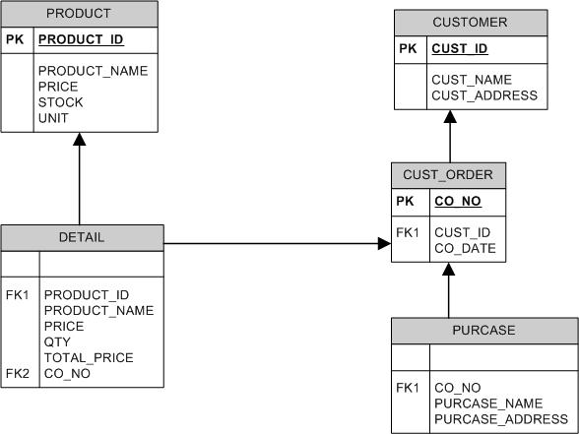
TABEL-TABEL
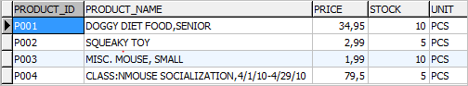
- TABEL BARANG

- TABEL CUSTOMER
- TABEL CUSTOMER ORDER
- TABEL PURCASE
- TABEL DETAIL
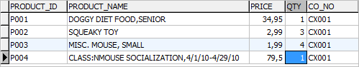
    - QUERY
CREATE DATABASE UAS

USE UAS

CREATE TABLE PRODUCT(
PRODUCT_ID CHAR(5)NOT NULL PRIMARY KEY,
PRODUCT_NAME CHAR(50),
PRICE FLOAT,
STOCK INT,
UNIT CHAR(10))

INSERT INTO PRODUCT(PRODUCT_ID,PRODUCT_NAME,PRICE,STOCK,UNIT)VALUES('P001','DOGGY DIET FOOD,SENIOR','34.95','10','PCS');
INSERT INTO PRODUCT(PRODUCT_ID,PRODUCT_NAME,PRICE,STOCK,UNIT)VALUES('P002','SQUEAKY TOY','2.99','5','PCS');
INSERT INTO PRODUCT(PRODUCT_ID,PRODUCT_NAME,PRICE,STOCK,UNIT)VALUES('P003','MISC. MOUSE, SMALL','1.99','10','PCS');
INSERT INTO PRODUCT(PRODUCT_ID,PRODUCT_NAME,PRICE,STOCK,UNIT)VALUES('P004','CLASS:NMOUSE SOCIALIZATION,4/1/10-4/29/10','79.50','5','PCS');

CREATE TABLE CUSTOMER(
CUST_ID CHAR (10)NOT NULL PRIMARY KEY,
CUST_NAME CHAR(50),
CUST_ADDRESS CHAR(50))

INSERT INTO CUSTOMER(CUST_ID,CUST_NAME,CUST_ADDRESS)VALUES('C001','SVETA CLARK','MENAGEIE WI')

CREATE TABLE CUSTOMER_ORDER(
CO_NO CHAR (10) NOT NULL PRIMARY KEY,
CUST_ID CHAR (10),
CO_DATE DATE)

INSERT INTO CUSTOMER_ORDER(CO_NO,CUST_ID,CO_DATE)VALUES('CX001','C001','2010/04/01')

CREATE TABLE DETAIL(
PRODUCT_ID CHAR (5),
PRODUCT_NAME CHAR (50),
PRICE FLOAT,
QTY INT,
CO_NO CHAR (10))

INSERT INTO DETAIL (PRODUCT_ID,PRODUCT_NAME,PRICE,QTY,CO_NO)VALUES('P001','DOGGY DIET FOOD,SENIOR','34.95','1','CX001');
INSERT INTO DETAIL (PRODUCT_ID,PRODUCT_NAME,PRICE,QTY,CO_NO)VALUES('P002','SQUEAKY TOY','2.99','3','CX001');
INSERT INTO DETAIL (PRODUCT_ID,PRODUCT_NAME,PRICE,QTY,CO_NO)VALUES('P003','MISC. MOUSE, SMALL','1.99','4','CX001');
INSERT INTO DETAIL (PRODUCT_ID,PRODUCT_NAME,PRICE,QTY,CO_NO)VALUES('P004','CLASS:NMOUSE SOCIALIZATION,4/1/10-4/29/10','79.50','1','CX001')

CREATE TABLE PURCASE(
CO_NO CHAR (10),
PURCASE_NAME CHAR(50),
PURCASE_ADDRESS CHAR(50))

INSERT INTO PURCASE(CO_NO,PURCASE_NAME,PURCASE_ADDRESS)VALUES('CX001','ROBERT TERWILLIGER','STREET 1265 PETLOVER LN APT.12 MENAGERIE WI 72827')

ALTER TABLE CUSTOMER_ORDER ADD CONSTRAINT FKG FOREIGN KEY (CUST_ID) REFERENCES CUSTOMER (CUST_ID) ON UPDATE CASCADE ON DELETE RESTRICT,ENGINE=INNODB;

ALTER TABLE PURCASE ADD CONSTRAINT FF FOREIGN KEY (CO_NO) REFERENCES CUSTOMER_ORDER (CO_NO) ON UPDATE CASCADE ON DELETE RESTRICT,ENGINE=INNODB;

ALTER TABLE DETAIL ADD CONSTRAINT FOK FOREIGN KEY (CO_NO) REFERENCES CUSTOMER_ORDER (CO_NO) ON UPDATE CASCADE ON DELETE RESTRICT,ENGINE=INNODB;

ALTER TABLE DETAIL ADD CONSTRAINT FT FOREIGN KEY (DPRODUCT_ID) REFERENCES PRODUCT (PRODUCT_ID) ON UPDATE CASCADE ON DELETE RESTRICT,ENGINE=INNODB;

CREATE TEMPORARY TABLE TEMP_DETAIL_TRANSAKSI
SELECT
CO_NO,
PRODUCT_ID,
PRODUCT_NAME,
PRICE,
DQTY,
PRICE*DQTY AS TOTAL_PRICE

FROM DETAIL JOIN PRODUCT ON PRODUCT.PRODUCT_ID =DETAIL.DPRODUCT_ID;

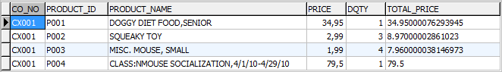
Hasil output

